

**TAGOLOAN COMMUNITY COLLEGE**

Baluarte, Tagoloan, Misamis Oriental

*Member: Association of Local Colleges and Universities (ALCU)*

*****Member: (ALCU-Commission on Accreditation)*

**COLLEGE OF INFORMATION TECHNOLOGY**

*Member: Philippine Society of Information Technology Educators (PSITE)*

**Development of Motorcycle Shop Inventory Management**

***Submitted by:***

*Mac Jan Well Quilang*

*Mhyco Chesli B. Ipong*

*Jose G. Marban*

*Ralf G. Quieta*

*Cristhianniel S. Maasin*

*Justine Clark Aurit*

***In partial fulfillment of the course***

***IT 112 Information Management 01***

***IT 114 Integrative Programming & Technologies 01***

***IT 115 Human Computer Interaction 01***

***IT 116 Advance Database System***

***2025***

**Table of Contents**

**Chapter 1**

Introduction……...…...……………………………………………….…..……………01

Objectives.………………………………………...……………….….……………….03

Scope and Limitation….……………….……………….………...…………………..04

**Chapter 2**

Review of Related Literature…………………………………………………………07

**Chapter 3**

**Data Model**

Normalize Table………………………………………………………..………………13

Logical Data Model………………………………...………………………………….14

Physical Data Model………………...………………………………………………...15

Conceptual Data Model……………………………………………………………….16

**Documentation**

Portfolio………………………………………………………………………………….17

Code Snippet……………………………………………………….…………………..24

System Snippet…………………………………………………………………………35

**Chapter 1**

**Introduction**

In busy municipalities where motorcycles are the king of the roads, neighborhood shops are the backbone of riders' everyday commutes. Shop owners, mechanics, and parts dealers work hard to keep these essential businesses running. However, most use manual processes such as notebooks, spreadsheets, or legacy software to manage inventory, track sales, and coordinate suppliers, a phenomenon prevalent in small- and medium-sized businesses (SMEs) in the automotive industry (Smith & Lee, 2020). Such disjointed systems tend to result in inefficiencies, mistakes, and delays in operations, emphasizing the necessity for immediate modernization.

Enter the Motorcycle Parts Management System (MPMS), an all-encompassing system crafted to make motorcycle parts businesses more efficient. We, an IT student Developed a system about problem-solving in the real world, MPMS merges inventory management point-of-sale activities, and sales analytics into one easy-to-use system. Developed in React for smooth user interaction and backed by a trusted Express + MySQL backend, the application provides auto features such as dropdown selection for suppliers and categories, product image uploads, and even sales reports in PDF format, all in a clean, easy-to-use interface designed with Bootstrap.

The costs of poor inventory management are great. Research indicates that companies that use manual systems are exposed to serious risks such as stockouts, overstocking, and workflow interruption (Gupta & Chen, 2019). For businesses like James & Boy Motorshop, such inefficiencies can translate to customer dissatisfaction and loss in profitability. MPMS resolves these issues by replacing error-prone manual logs with real-time tracking of inventory, automated low-stock notifications, and centralized access to data. Johnson et al. (2021) research shows how real-time tracking systems decrease human error by 30% and enhance decision-making speed by 45%, which is consistent with MPMS's objective of operational accuracy.

Additionally, MPMS closes the gap between sales and inventory data and minimize waste. The integration is essential because Thompson and Rodriguez (2022) discovered that cohesive management systems improve the rate of inventory turnover by 25% in the automotive repair SMEs. By automating processes, MPMS not only conserves time but also provides improved financial visibility—a major scalability driver in competitive environments. MPMS is not just a technological advancement, but a strategic shift. By encouraging precision, efficiency, and data-based planning, the system empowers companies such as James & Boy Motorshop to excel in a changing world—showing that the proper equipment can transform day-to-day operations into growth machines. Without effective inventory systems, companies stand to lose through wasteful space allocation, incorrect records, and ongoing utility disruption. An effective Inventory Management System(IMS) addresses these concerns by replacing inefficient traditional methods with an automated, centralized platform that is smart. The MPMS designed through this work is set to do the same: simplify the process and advance utility in how James & Boy Motorshop handles their inventory. The system enables staff to track real-time stock levels, sort items by supplier or part type, and produce reports that aid planning, auditing, and procurement. No more scribbled logs and last-minute surprises—now low-stock warnings, tidy records, and sales tracking are just a few clicks away.

Furthermore, the MPMS combines sales tracking with inventory management, allowing for easier identification of high-turning items, improved purchasing decisions, and the assurance that parts are available for repair. Automating these functions provides the shop with greater visibility into operations, eliminates human error, and saves precious time that can be better utilized to serve customers. This is not merely a digital enhancement; it's a strategic step ahead. Through increased inventory accuracy, facilitating improved planning, and improved coordination between departments, the MPMS provides a foundation for scalable growth, financial effectiveness, and stable service quality. As James & Boy Motorshop continues to cater to its local market, the Motorcycle Parts Management System will be an essential tool in helping it stay competitive, responsive, and ready for the challenges of an increasingly dynamic industry.

On March 16, 2025, we conducted an interview with the owner of James & Boy Motor Shop to understand the challenges and problems they face in managing their inventory. During the interview, the owner shared several issues with their current inventory management process, which is entirely manual. These issues include missing items, uncounted products, mispriced items, and inaccurate stock monitoring. Their current method relies solely on manual counting, which is time-consuming, prone to human error, and inefficient—especially as the shop grows and handles more products. To address these challenges, we proposed the development of a Motorcycle Shop Inventory Management System specifically tailored to the needs of James & Boy Motor Shop. This system aims to streamline and automate their inventory processes, reducing errors and saving time. It will allow them to accurately track stock levels, prices, and product details in real time. The system is designed to be user-friendly and easy to navigate, ensuring that even staff with minimal technical skills can use it effectively. By implementing this solution, the shop can improve its operational efficiency, minimize inventory discrepancies, and make better business decisions based on accurate da

**2**

**Objectives**

The main objective of this project is to design, develop, and implement a comprehensive Motorcycle Parts Inventory Management System (MPIMS) for James & Boy Motorshop that streamlines and automates core inventory and sales operations. The system aims to replace the existing manual processes with a scalable, efficient, and user-friendly digital platform that improves inventory accuracy, enhances decision-making through real-time data and reporting, and supports the overall digital transformation of the business.

**Specific Objectives:**

* To provide detailed product information, including category, supplier, price, quantity, and images.
* To analyze the existing inventory management practices of James & Boy Motor Shop and identify inefficiencies and challenges in the current manual system.
* To design and develop a computerized inventory management system that allows for real-time tracking of motorcycle parts, automated stock updates, and easy monitoring of inventory levels.
* To display alerts for low-stock products to help users manage inventory effectively.
* To implement key features such as inventory alerts, sales tracking, and reporting tools that aid in informed decision-making.
* To offer a comprehensive overview of the system's performance, including key metrics like total products, categories, suppliers, and sales revenue.
* To support the digital transformation of small to medium-sized motorcycle businesses by providing a scalable, practical, and modern inventory management solution.
* To enable users to add, edit, and delete product records efficiently through a user-friendly interface.
* To allow users to manage product categories by adding, editing, and deleting them, and to provide a structured and organized view of all categories.
* To facilitate supplier management by allowing users to add, edit, and delete supplier records, including details such as name, contact information, and address.
* To provide tools for managing sales records, including the ability to add and delete transactions, and to export sales data into PDF reports for documentation and analysis.
* To offer quick access to frequently used actions such as adding products, categories, and suppliers directly from the system dashboard for enhanced usability.
* To fetch and display data for products, categories, suppliers, and sales using backend APIs, ensuring real-time updates and seamless synchronization with the database.

**3**

**Scope and Limitation**

**Scopes of the Application**

**1. Dashboard Overview**

* Displays key metrics such as total products, categories, suppliers, and sales revenue.
* Provides alerts for low-stock products based on predefined thresholds.
* Includes sections for recent activity, sales overview (chart placeholders), and quick access to frequently used actions.

**2. Product Management**

* Allows users to add, edit, and delete product records.
* Supports image uploads for individual products.
* Displays detailed product information, including name, category, supplier, price, quantity, and image.
* Integrates with category and supplier modules for assigning related data.

**3. Category Management**

* Enables adding, editing, and deleting product categories.
* Displays a searchable and paginated list of all categories for better organization and navigation.

**4. Supplier Management**

* Allows users to add, edit, and delete supplier information.
* Includes input fields for supplier name, contact details, and address.
* Displays a searchable and paginated list of all suppliers.

**5. Sales Management**

* Supports the addition and deletion of sales records.
* Allows users to export sales data as a PDF report for documentation and analysis.
* Displays sales records in a searchable, sortable, and paginated table.
* Includes a modal for creating new sales transactions with product selection and quantity input.

**6. Navigation and Layout**

* Provides a fixed header with a search bar and a sticky sidebar for intuitive navigation.
* Includes links to all core sections: Dashboard, Products, Categories, Suppliers, and Sales.

**7. Data Fetching and API Integration**

* Retrieves data for products, categories, suppliers, and sales via backend APIs.
* Uses React's useEffect hook to load data when components are mounted, ensuring real-time updates.

**8. UI/UX Features**

* Utilizes modals for adding, editing, and deleting records across the system.
* Implements a responsive layout using grid systems and Bootstrap-based styling.
* Incorporates visual elements such as badges and alerts to provide feedback and enhance user experience.

**Limitations of the Application**

**1. Validation**

* Input validation is limited to basic checks.
* There is no advanced validation for numeric fields, file types, file sizes, or API response handling.

**2. Image Handling**

* Image uploads are handled via a backend URL, but lack proper validation for file type and file size.
* There is no preview feature for uploaded images before submission, which could affect user experience.

**3. Scalability**

* The application currently fetches all data at once for products, categories, and suppliers, which may lead to performance issues with large datasets.
* There is no implementation of lazy loading or server-side pagination to optimize data handling at scale.

**4. State Management**

* State is managed locally within individual components using useState.
* There is no global state management solution (e.g., Redux or Context API), which limits data sharing across components and can affect maintainability as the application grows.

**5. User Authentication**

* All features are accessible only to admin users.
* There is no implementation of role-based access control or user-level permissions.

**6. Accessibility**

* The application has limited accessibility features.
* It lacks ARIA roles, keyboard navigation support, and other best practices for making interactive components accessible to users with disabilities.

**7. Mobile Responsiveness**

* While the application uses responsive design principles, some UI elements such as modals and grid layouts may not be fully optimized for smaller screens and mobile devices.

**8. Localization and Internationalization**

* The system does not support multiple languages or regional formatting for currencies, dates, and numbers, limiting its adaptability for users in different locale

**Chapter 2**

**Review of Related Literature**

**Local Related Literature**

According to Angelo H. Barcelona“It is primarily very essential in any kind of business, specifically in motor cycle parts supply business. Because if you do not maintain an optimum stock level, it can directly affect your profitability and also satisfaction among customers. This is what it involves: the tracking, ordering, storing, and selling of a company’s stock. It ensures that the important parts and products will be available when they are needed, without bearing up all of the high costs for holding a lot of inventories or suffering from stockouts. This research was done to analyze the inventory management strategies of auto supply businesses in Candelaria, Quezon. A survey was made to nine (9) business owners/managers. Though the sample size does not seem huge, it makes a significant part of the local industry and will surely provide pertinent information for this research study. The research uncovered barriers mostly like the “compliance-related expenses” to obtain permits, licenses, and certifications from the local government units and “inventory fluctuations” that impede effective inventory management. The advice to use a “just-in-time” (JIT) inventory system is highly beneficial: it has the potential to cut costs by reducing the amount of inventory carried at all times, thus lowering storage expenses and cutting down the risk of excess stock without a ready market. This has the effect of ensuring that inventory is ordered only as required rather than being stored as excess stock that may become obsolete due to non-use or taking up very valuable space.

According to Abigail Sanico“Business evaluation would be another vital thing that every enterprise has to carry out from time to time. They have to store their goods well to ensure that they have the right amounts of products available when their customers need them. They also need to know if they are losing too much money because of overstocking their products. Thus, the research seeks to critically analyze how services on inventory management would benefit, not just the small and medium enterprises in developing their inventory systems, but also create more efficient and productive enterprises. An example of a small enterprise being studied is Sunbird School, Office Supplies and Gift Shop, which served as the host enterprise or company of the researchers. The enterprises are having problems in their inventory management where due bad forecasts they ordered too much and led to excessive stocks.. Products and items that remain stored for a long time suffer from damage, making them unfit for sale. Thus, the researchers decided to conduct the study with the aim of providing inventory audit and inventory consulting services to small and medium enterprises. These target markets are specifically

According to Tan et al. (2022), a home service application information system was proposed to facilitate the sale and repair of motor vehicle spare parts. The system's sales management features allowed customers to purchase products online and schedule service appointments, thereby enhancing convenience and enabling more efficient tracking through computerized sales processes. The findings of their research highlight several advantages of integrating sales management functionalities into customer service operations, ultimately contributing to the improvement of overall business processes.

According to Smith et al. (2023), the sales and inventory system developed in their study provides a structured approach to managing items. The system offers robust features for item sub-categorization, detailed descriptions, and tracking, which significantly streamline the process of searching and managing inventory. Their research demonstrates a practical example of effective item control, contributing to improved operational efficiency and greater inventory accuracy.

According to Gonzales et al. (2021), a sales and inventory management information system was designed for a motorcycle parts and accessories store. The system incorporated key components such as inventory tracking, real-time updates, and automated alerts for reordering, all aimed at improving inventory accuracy and preventing stock-out situations. The study highlights how automation can enhance stock management by minimizing manual errors and streamlining inventory processes

**Foreign Related Literature**

According to Deutch (2020), a point-of-sale (POS) system allows a business to receive and process payments from customers. While the concept may seem straightforward, its implementation can vary depending on whether the business operates online, in a physical store, or both. Modern POS systems are fully computerized, enabling employees to access customer information and transaction details at any time. These systems typically involve both software and internet-connected devices. The relevance of Deutch’s work to this research lies in its exploration of how POS systems function and support businesses. The article highlights how such systems assist employees and business owners in monitoring customer activity and managing transactions effectively.

According to Saeed Ullah Jan, Khalid Shah, and Niaz Mand (2023), a point-of-sale (POS) system is a type of business management software designed to perform various tasks such as creating seller profiles, adding products, generating and summarizing sales reports, and managing account-related functions. Their project aims to introduce a POS system with enhanced and flexible features as an alternative to traditional manual methods. The primary objective is to enable more efficient inventory management within retail environments. The scope of the system includes database management, report generation, quality control (QC), and streamlined point-of-sale operations. Designed for web-based access, the system also prioritizes a user-friendly interface to ensure accessibility for users with little or no technical background. Ultimately, the system is intended to reduce the time and paperwork involved in POS management for shops, stores, and small businesses.

According to Rahman et al. (2022), the gradual adoption of technology and the digitalization of business processes offer a practical solution for small and medium enterprises (SMEs) in Bangladesh to enhance inventory management and reduce human error in sales operations. Real-time tracking and decision-making capabilities integrated into sales and inventory systems significantly contribute to the efficiency of SME operations and improve overall customer satisfaction.

According to Hasan et al. (2022), in their study titled "Sales and Inventory Management Practices for Motor Parts Retail in Dhaka City: A Case Study", the research investigates the sales and inventory management practices within the motor parts retail sector in Dhaka. The case study explores the practical challenges of managing stock and sales operations, while also proposing potential solutions for improving efficiency in the retail industry. The findings highlight the significant role of technology in streamlining processes and enhancing the overall effectiveness of inventory management.

According to Saeed Ullah Jan, Khalid Shah, Niaz Mand Available at SSRN 4368998, 2023 A point-of-sale is a business managing software that will allow you to make a seller, enter a product, create a sales report, summarize sales, and carry out activities related to accounts, among other things. The need for the project is to provide a system able to have enhanced and flexible functionalities into the shop by presenting a point of sale (POS) System that can replace the manual methods that were used before. It aims to provide capabilities for more efficient inventory management in the shop. The scope of the project would entail working on such issues as database issues, report generation, QC, and point of-sales operations within the store to uphold the common objectives. The system will be developed as an offline or window-based system and some access through browsers will be given. As per the aims of the system, it is expected that the user interface be user friendly so that laypersons with no computer background can use it easily. Moreover, the system aims to carry out all these activities and help any store/small shop/small business decrease time and paperwork associated with POS management

**5**

**SYNTHESIS**

The implementation of a Point of Sale (POS) system significantly enhances the efficiency and accuracy of business operations. According to Khalid and Mand (2022), a POS system enables real-time access to sales and inventory data, providing both customers and business partners with up-to-date information. This level of transparency and efficiency allows for faster and more reliable processing of goods and services.

POS systems commonly include features such as product listings, quantity tracking, pricing, and transaction handling. The transaction module allows users to input item names, prices, and quantities, as well as the amount paid by the customer. Secure login credentials are required to access and manage transactions, including the addition and deletion of data. This security feature ensures controlled access to system functions.

The reviewed literature and prior research greatly influenced the study and development of the system. While similar in user-friendly features and technological design, the proposed system offers improvements and adaptations based on modern needs. Unlike manual processes that are prone to errors and repetitive tasks, POS systems streamline inventory management, automate sales computations, and generate accurate reports.

One of the key distinctions in modern POS implementations is the ability to access the system online or through cloud computing. This allows for greater mobility and efficiency, enabling businesses to operate proactively using laptops and web browsers. Cloud-based POS software also ensures data is synchronized and accessible in real time, reducing dependency on physical storage.

The study follows the Requirement Analysis or Requirement Engineering Method, recognizing that all software development should begin with clearly defined needs. These requirements serve as the foundation for designing a system that effectively addresses business challenges, particularly in tracking inventory, calculating sales, and producing detailed sales reports through a user-friendly interface.

In conclusion, POS systems today are designed to reduce human error, automate essential tasks, and support business scalability. Their adaptability, whether web-based or cloud-powered, makes them a practical solution for modern business operations.

**Chapter 3**

**Normalization and Data Modeling**

Chapter 3 discusses the importance of organizing data efficiently using normalization and applying appropriate data modeling practices. These methods are essential in minimizing redundancy, maintaining data integrity, and designing scalable databases. The motorcycle parts management system applies these principles by decomposing raw transactional data into well-structured relational tables.

**3.1 Normalization**

Normalization is a systematic approach in relational database design that transforms raw data into logically organized tables. By applying normalization rules— First Normal Form (1NF), Second Normal Form (2NF), and Third Normal Form (3NF)— data is broken down into smaller, non-redundant units while preserving relationships. In the motorcycle parts system, the transformation begins with a basic unnormalized table that contains repeated and redundant data. The goal is to organize data into related entities such as categories, suppliers, products, and sales, which reduces duplication and improves consistency.

***1NF – First Normal Form***

To achieve 1NF, we ensure that all values in a table are atomic (no repeating groups or arrays). Below is an example of unnormalized data that mixes product and supplier’s contact info:

|  |  |  |  |  |  |  |  |
| --- | --- | --- | --- | --- | --- | --- | --- |
| **product_id** | **name** | **Category** | **Supp_name** | **Contact_info** | **Address** | **Price** | **quantity** |
| 1 | Prod_1 | Cat_1 | Supp_1 | 09123456789 | Poblacion | ₱100.00 | 10 |
| 2 | Prod_2 | Cat_2 | Supp_2 | 09123456788 | Sta. Ana | ₱200.00 | 20 |
| 3 | Prod_3 | Cat_3 | Supp_3 | 09123456787 | Mohon | ₱300.00 | 30 |

This data violates 1NF due to repeating supplier information. After applying 1NF, we separate product and supplier details.

**Products table:**

|  |  |  |  |  |  |
| --- | --- | --- | --- | --- | --- |
| **product_id** | **name** | **Category** | Supplier_id | **Price** | **quantity** |
| 1 | Prod_1 | Cat_1 | 1 | ₱100.00 | 10 |
| 2 | Prod_2 | Cat_2 | 2 | ₱200.00 | 20 |
| 3 | Prod_3 | Cat_3 | 3 | ₱300.00 | 30 |

**Suppliers table:**

|  |  |  |  |
| --- | --- | --- | --- |
| **supplier_id** | **Supp_name** | **Contact_info** | **Address** |
| 1 | Supp_1 | 09123456789 | Poblacion |
| 2 | Supp_2 | 09123456788 | Sta. Ana |
| 3 | Supp_3 | 09123456787 | Mohon |

***2NF – Second Normal Form***

2NF eliminates partial dependencies by ensuring that all non-key attributes are fully functionally dependent on the entire primary key. We now separate data into independent entities.

**Categories table:**

|  |  |
| --- | --- |
| **Category_id** | **name** |
| 1 | Cat_1 |
| 2 | Cat_2 |
| 3 | Cat_3 |

**Suppliers table:**

|  |  |  |  |
| --- | --- | --- | --- |
| **supplier_id** | **Supp_name** | **Contact_info** | **Address** |
| 1 | Supp_1 | 09123456789 | Poblacion |
| 2 | Supp_2 | 09123456788 | Sta. Ana |
| 3 | Supp_3 | 09123456787 | Mohon |

**Products table:**

|  |  |  |  |  |  |
| --- | --- | --- | --- | --- | --- |
| **product_id** | **name** | **Category_id** | **Supplier_id** | **Price** | **quantity** |
| 1 | Prod_1 | Cat_1 | 1 | ₱100.00 | 10 |
| 2 | Prod_2 | Cat_2 | 2 | ₱200.00 | 20 |
| 3 | Prod_3 | Cat_3 | 3 | ₱300.00 | 30 |

Here, the products table references categories and suppliers using foreign keys, thereby eliminating redundancy and improving referential integrity.

***3NF – Third Normal Form***

3NF removes transitive dependencies—non-key attributes that depend on other non-key attributes.

**Sales table:**

|  |  |  |  |  |  |  |  |  |  |
| --- | --- | --- | --- | --- | --- | --- | --- | --- | --- |
| **Sale_id** | **Product_id** | **Product_name** | **Customer_name** | **Quantity** | **price** | **Total_price** | **Discount** | **Payment_type** | **Sale_date** |
| 1 | 1 | Prod_1 | Jon Snow | 2 | ₱100.00 | ₱200.00 | 0 | Cash | 2024-04-10 |
| 2 | 2 | Prod_2 | Rhaegar | 3 | ₱200.00 | ₱600.00 | 0 | gcash | 2024-04-10 |
| 3 | 3 | Prod_3 | Lyanna | 4 | ₱300.00 | ₱1200.00 | 0 | maya | 2024-04-10 |

The sales table references products by product_id and maintains all sales-related attributes. Product name is stored here for reporting purposes and it is derived via join, to avoid redunda

**3.2 Data Modeling**

Data modeling is the process of conceptualizing and organizing data elements, along with their interrelationships, to support the development of a structured, efficient, and scalable database system. It provides a blueprint that guides the design and implementation of a system's data layer—from high-level conceptual planning to detailed physical schema creation. In our project, Motorcycle Parts Management System, data modeling was used to define the structure and flow of information related to motorcycle parts, suppliers, product inventory, and sales transactions. The goal was to ensure that all critical system components—including categories, products, suppliers, and sales—were logically and consistently represented. By employing entity- relationship diagrams (ERDs) and normalization techniques, the model was refined to eliminate redundancy, enforce referential integrity, and support future scalability. The resulting data model allows for efficient data retrieval and accurate record-keeping, which are essential for managing inventory, tracking sales, and maintaining supplier records. This structured approach ultimately supports the system’s goal of providing a reliable and user-friendly management platform for motorcycle parts and transactions.

**6**

**3.2.1 Conceptual Data Model**

The conceptual data model serves as a high-level abstraction of the database structure, focusing on the core entities within the Motorcycle Parts Management System and the relationships that connect them. It establishes a foundational perspective that will guide the subsequent logical and physical design stages.

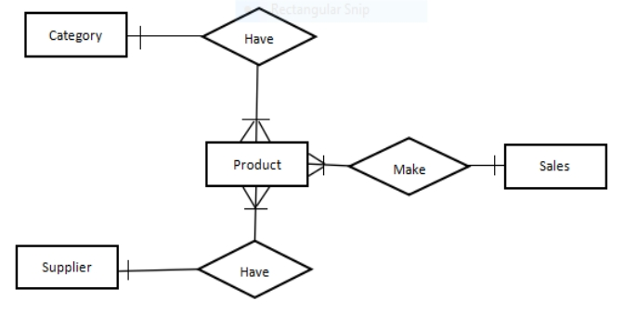

**Figure 1. Conceptual Data Model**

Figure 1 illustrates the conceptual data model of the Motorcycle Parts Management System. The diagram defines four principal entities: Category, Product, Supplier, and Sale. These entities are connected through relationships that reflect the system’s operational structure. The Category entity has a one-to-many relationship with the Product entity, meaning one category can have many products. Likewise, the Supplier entity has a one-to-many relationship with the Product entity, indicating one supplier can provide many products. The Product entity is linked to the Sale entity, showing that a product can be part of multiple sales transactions, each of which details the product sold, quantity, price, and customer information.

**7**

**3.2.2 Logical Data Model** The logical data model builds upon the conceptual data model by introducing greater detail regarding the structure and relationships within the database. Although it remains implementation-independent, the logical model defines specific attributes, primary keys (PK), and foreign keys (FK) for each entity. This serves as a transitional layer between high-level system design and physical database implementation.

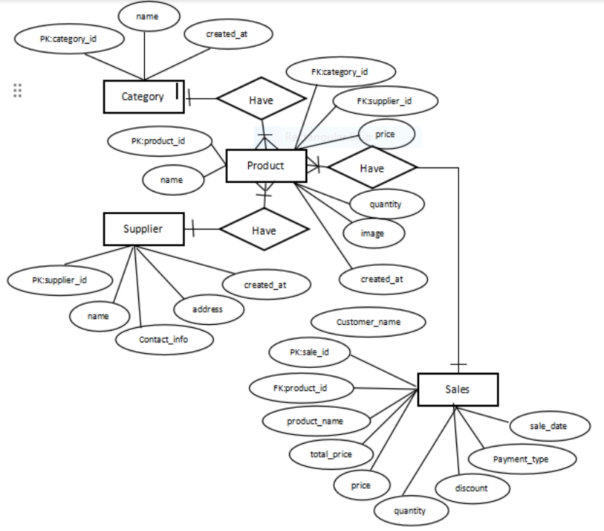

**Figure 2. Logical Data Model**

Figure 2 presents the Motorcycle Parts Management System's logical data model features four key entities: Categories, Suppliers, Products, and Sales, each defined by specific attributes and keys for database clarity and consistency. The Categories entity has a category_id (PK) and name. The Suppliers entity includes supplier_id (PK), name, contact_info, and address. The Products entity comprises product_id (PK), name, category_id (FK), supplier_id (FK), price, quantity, and image, linking each product to a specific category and supplier for efficient organization and sourcing. Finally, the Sales entity details transactional data with sale_id (PK), product_id (FK), product_name, customer_name, quantity, price, discount, total_price, payment_type, and sale_date. The model establishes the following relationships: one Category to many Products, one Supplier to many Products, one Product to many Sales, and each Sale to a specific Product. This design ensures referential integrity and promotes data accuracy, consistency, and scalability.

**8**

**3.2.3 Physical Data Model**

The physical data model represents the most concrete and implementation-focused level of database design. It outlines how data is physically stored in the database system, specifying the exact data types, sizes, constraints, and relationships. This model is crucial for developers and database administrators to ensure that the system meets performance, scalability, and integrity requirements.

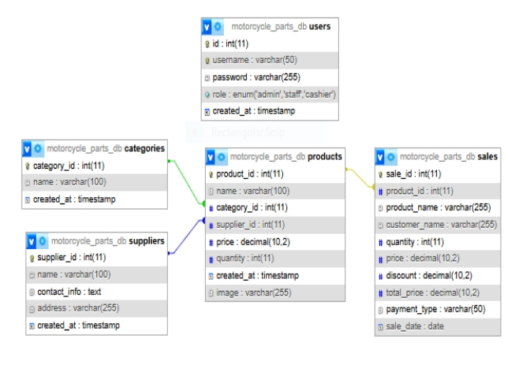

**Figure 3. Physical Data Model**

Figure 3 presents the physical data model for the Motorcycle Parts Management System, translating the logical data structures into SQL-ready table schemas designed for deployment in a relational database such as MariaDB. This model comprises four main tables: Categories, Suppliers, Products, and Sales. The Categories table includes category_id as the primary key (integer, auto-increment), a non-nullable name (varchar(100)), and a non-nullable created_at timestamp with a default current timestamp. The Suppliers table features supplier_id as the primary key (integer, auto-increment), a non-nullable name (varchar(100)), nullable contact_info (text) and address (varchar(255)), and a non-nullable created_at timestamp with a default current timestamp. The Products table incorporates product_id as the primary key (integer, auto-increment), a non-nullable name (varchar(100)), nullable foreign keys category_id and supplier_id (both integers referencing the respective primary keys in the Categories and Suppliers tables), nullable price (decimal(10,2)) and quantity (integer), a non-nullable created_at timestamp with a default current timestamp, and a nullable image path (varchar(255)). Lastly, the Sales table contains sale_id as the primary key (integer, auto-increment), a nullable foreign key product_id (integer referencing the primary key in the Products table), nullable fields for product_name (varchar(255)), customer_name (varchar(255)), quantity (integer), and price (decimal(10,2)), a discount (decimal(10,2)) with a default value of 0.00, a nullable total_price (decimal(10,2)), a nullable payment_type (varchar(50)), and a nullable sale_date (date). This schema is structured to maintain data consistency through foreign key relationships, support scalability via normalized tables, ensure storage efficiency with appropriately sized data types, and preserve referential integrity across entities, ultimately optimizing the database for query performance and long-term maintainability.

**9**

**Interview Questioner**

**1.** How do you currently handle sales transaction in your shop?

2. What are the biggest challenges you face in managing sales and inventory

3. What payment methods do you accept cash, credit or debit card, e-wallets or gcash?

4 How do you process refunds, return, or exchanges for customer?

5. How do you manage your inventory manually, spreadsheet, software?

6.What problem do you face when managing your sales and inventory

7. Which motorcycle brand or model have the highest demand for parts?

8. What specific feature do you want in a Point-of-sale system to improve

9. How do you handle out off stock items?

10. What types of reports would be useful for tracking your business performance? daily sales,

best-selling items, stock levels

11.What problems do you face when managing your sales and inventory?

12. How often do you conduct stock audits or inventory check?

13.What security feature would you like to include?

14.Where do you store your transaction records

15.How do you manage customer records, receipt, and sales reports?

**Findings**

1. Manually using logbooks or notebooks.

2.Difficulty tracking stock and sales accurately.

3.Cash and GCash.

4.Handled manually through receipt verification.

5.Manual using notebooks or physical records.

6.Human error and missing records.

7.Honda and Rusi models.

8.Accurate inventory tracking and real-time updates.

9.We list and reorder when customers request.

10.Daily sales, best-selling items, and current stock levels.

11.ifficulty updating inventory and tracking items sold.

12..Once a month.

13.User logins and password protection.

14.Stored in notebooks or physical folders.

15.Manually written in logbooks or receipt books.

**11**

**DOCUMENTS**



**MHYCO CHESLI B. IPONG**  
Casinglot, Tagoloan Misamis Oriental

Mobile: 09058844309  
Email: ipongmico@gmail.com

**PERSONAL INFORMATION**

**Birthdate:** June 7,2005  
**Birthplace:** Cagayan de Oro City  
**Age:** 19  
**Nationality:** Filipino

**EDUCATIONAL BACKGROUND**

**Tertiary Education:**

* **Tagoloan Community College**  
  Baluarte, 9001 Tagoloan Misamis Oriental

**Secondary Education:**

* TSHS-Tagoloan Senior High School  
  Tagoloan Misamis Oriental (2022–2023)
* **Casinglot National High School**  
  Casinglot, Tagoloan Misamis Oriental (2020–2021)

**Primary Education:**

* **Casinglot Elementary School**  
  Casinglot, Tagoloan Misamis Oriental (2016–2017)

**TITLE PROJECT: Development of Motorcycle Shop Inventory Management**

**RALF D. QUIETA**   
Damilag Manolo Fortich Bukidnon  
Mobile: 09651977797  
Email: flarmiller@gmail.com

**PERSONAL INFORMATION**

**Birthdate:** August 23, 2004  
**Birthplace:** Cebu City  
**Age:** 20  
**Nationality:** Filipino

**EDUCATIONAL BACKGROUND**

**Tertiary Education:**

* **Tagoloan Community College**  
  Baluarte, 9001 Tagoloan Misamis Oriental

**Secondary Education:**

* **LNHS - Libona Senior High School**  
  Libona National High School (2022–2023)
* **Libona National High School**  
  Crossing, Libona, Bukidnon (2020–2021)

**Primary Education:**

* **Crossing Elementary School**  
  Libona, Bukidnon (2015–2016)

**TITLE PROJECT: DEVELOPMENT OF MOTORCYCLE SHOP INVENTORY MANAGEMENT**

**CRISTHIANNIEL S. MAASIN**   
San Martin, Villanueva Misamis Oriental  
Mobile: 09364276270  
Email: mcristhianniel@gmail.com

**PERSONAL INFORMATION**

**Birthdate:** August 16, 2004  
**Birthplace:** San Martin  
**Age:** 20  
**Nationality:** Filipino

**EDUCATIONAL BACKGROUND**

**Tertiary:**

* **Tagoloan Community College**  
  Baluarte, 9001 Tagoloan Misamis Oriental

**Secondary:**

* **LMA - Little Me Academy**  
  Cagayan De Oro (2022–2023)
* **Tagoloan National High School**  
  Tagoloan, Misamis Oriental (2020–2021)

**Primary:**

* **San Martin Elementary School**  
  San Martin, Villanueva, Misamis Oriental (2015–2016)

**TITLE PROJECT: DEVELOPMENT OF MOTORCYCLE SHOP INVENTORY MANAGE**

**MAC JAN WELL P. QUILANG**  
Sta. Ana, Tagoloan, Misamis Oriental  
Mobile: 0981 5353 2539  
Email: macjanquilang123@gmail.com

**PERSONAL INFORMATION**

**Birthdate:** January 18, 2003  
**Birthplace:** Sta. Ana, Tagoloan, Misamis Oriental  
**Age:** 22  
**Nationality:** Filipino

**EDUCATIONAL BACKGROUND**

**Tertiary Education:**

* **Tagoloan Community College**  
  Baluarte, 9001 Tagoloan Misamis Oriental

**Secondary Education:**

* **Informatics CDO(SHS)**2/F, Stary Building, 9000, Max Y. Suniel St, Carmen, Cagayan de Oro (2019–2021)
* **Sta. Ana National High School**  
  Sta. Ana, Tagoloan, Misamis Oriental (2015–2019)

**Primary Education:**

* **Sta. Ana Elementary School**  
  Sta. Ana, Tagoloan, Misamis Oriental (2009–2015)

**TITLE PROJECT: Development of Motorcycle Shop Inventory Management**

**18**

**CODE SNIPPET**

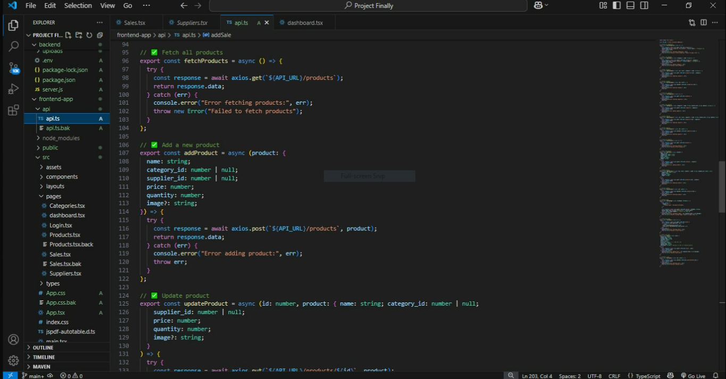

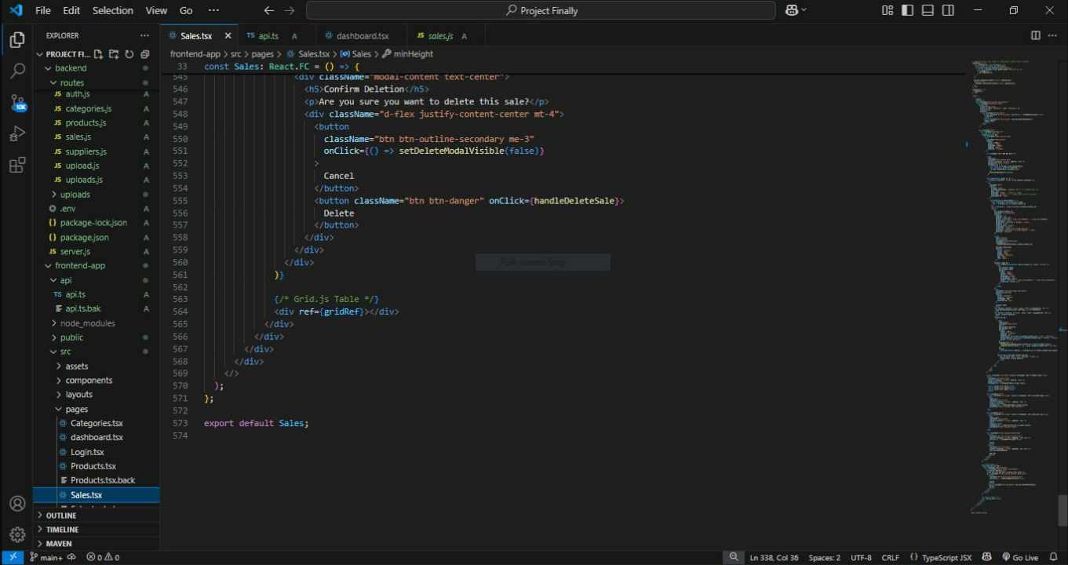

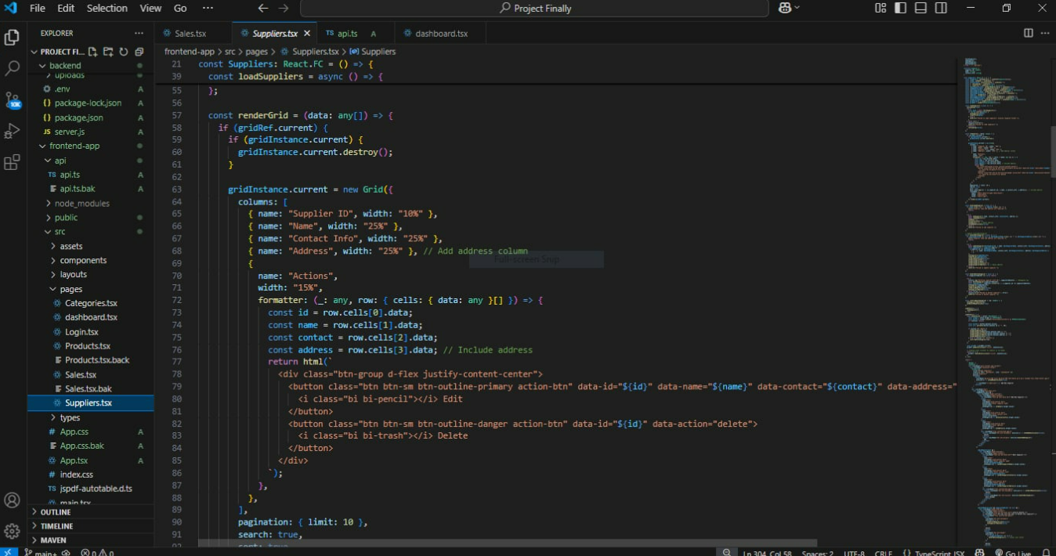

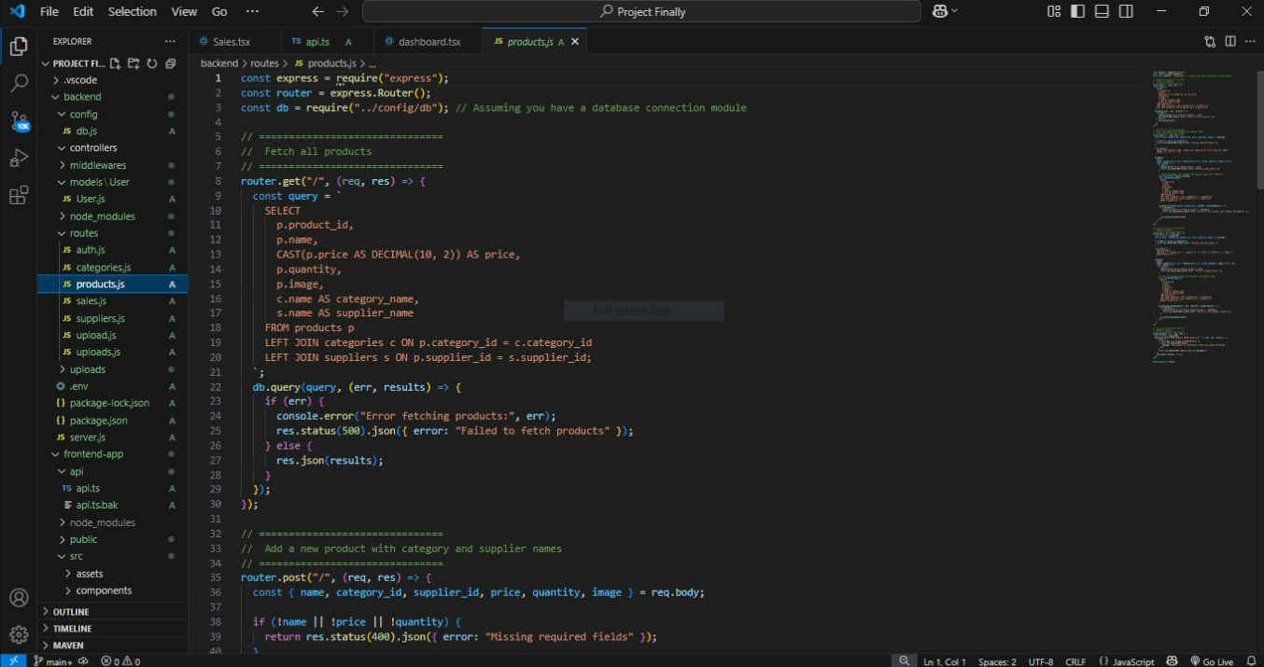

**20**

**SYSTEM SNIPPET**

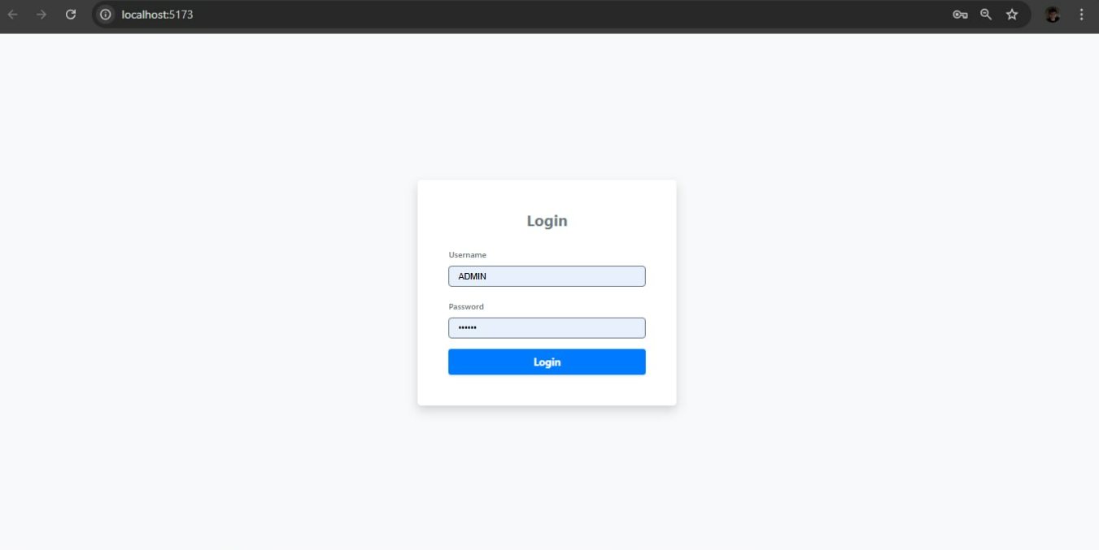

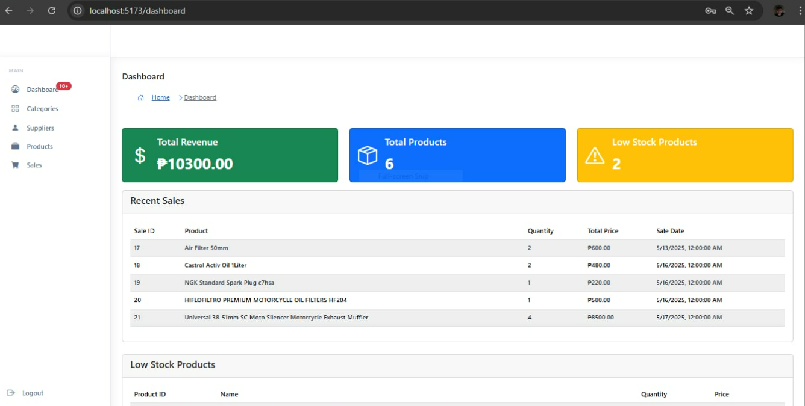

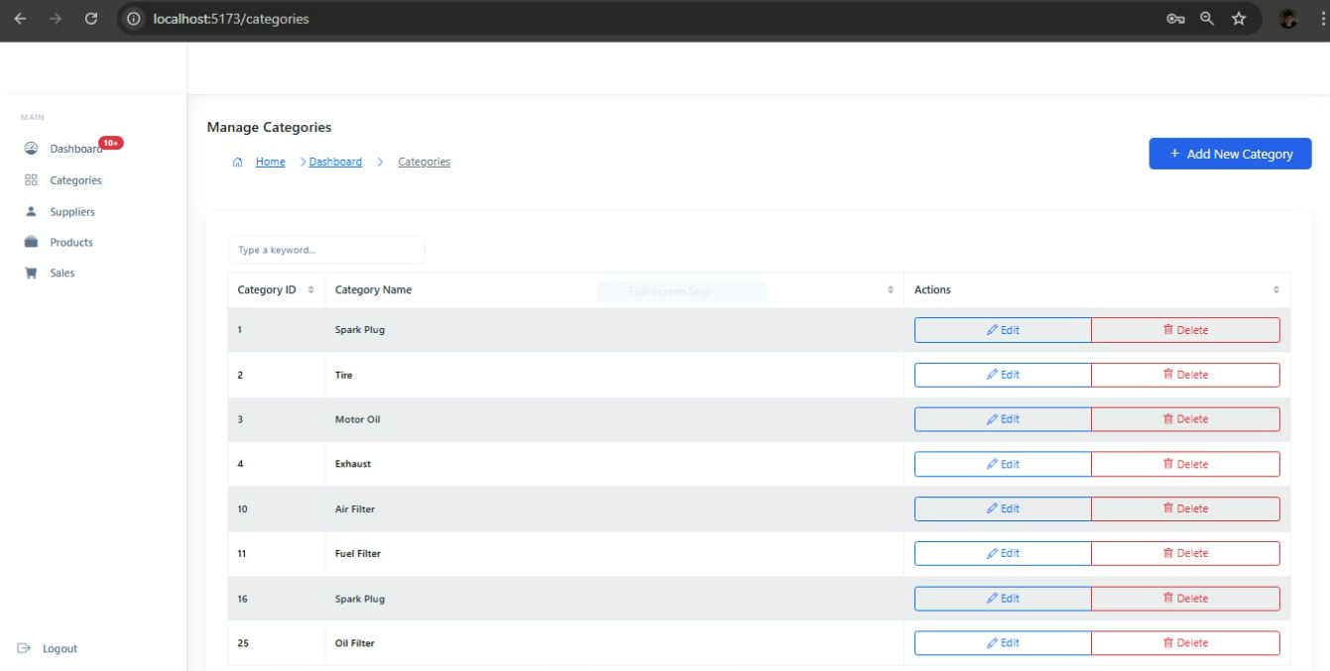

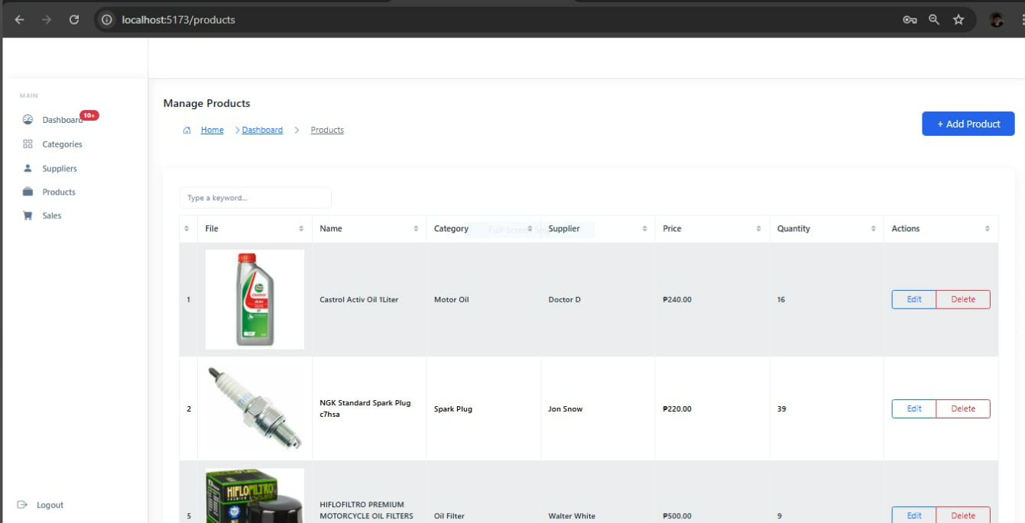

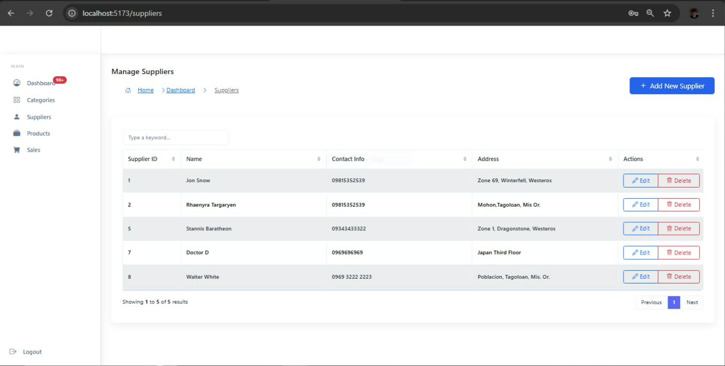

**21**

**References**

Gonzales, A., et al. (2021). *Implementation of a sales and inventory management information system for a motorcycle parts store*. Retrieved from <https://www.researchgate.net/publication/352978619>

Smith, R., & Lee, K. (2022). *Creation of a robust item management sales and inventory system*. Retrieved from https://typeset.io/papers/motor-sparepart-sales-application-new-sci-kamah-rudi-spare-k8lm4bdl

Rodriguez, P., & Hernandez, L. (2020). *Development of a web-based platform for automating sales and inventory processes*. Retrieved from https://typeset.tw/papers/development-of-a-web-based-platform-for-automating-an-267tgn4f

Pasaribu, S. J. (2021). Development of a web-based inventory information system. *International Journal of Engineering, Science and Information Technology, 1*(2). <https://doi.org/10.52088/ijesty.v1i2.51>

Singh, A., & Johnson, M. (2022). Sales force management in the automotive industry: A case study of Tata Motors. *Journal of Business Research*. https://www.emerald.com/insight/content/doi/10.1108/RAMJ-09-2022-0145/full/html

Digital Schools of Marketing. (2020). *Understanding point-of-sale systems*. Retrieved from http://103.47.12.35/bitstream/handle/1/1650/1713203027_Raj_Kumar_FinalProjectReport%20%20Raj%20kumar%20pachouri.pdf?sequence=1&isAllowed=y

IEOM Society. (2023). *Proceedings of the 2023 Manila Conference*. Retrieved from <https://ieomsociety.org/proceedings/2023manila/480.pdf>

ResearchGate. (n.d.). Retrieved from <https://www.researchgate.net/>

Hasan, M. N., Ahmed, S., & Hossain, M. M. (2022). Sales and inventory management practices in motor parts retail: A case study of Dhaka City. *Journal of Research in Marketing and Entrepreneurship*. <https://www.emerald.com/insight/content/doi/10.1108/RAMJ-09-2022-0145/full/html>

Rahman, T., & Lee, C. (2020). Development of a web-based inventory management system for motor parts. *International Journal of Information Management*. Square. (n.d.). *What is a POS system?* Retrieved from <https://squareup.com/us/en/townsquare/what-pos-system>